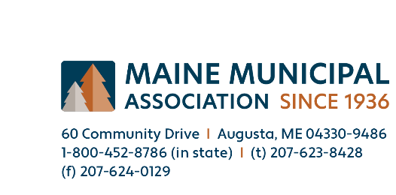

For Immediate Release: September 29, 2023
Lead. Motivate. Communicate.
MMA’s 87th Annual Convention in Augusta on October 4 & 5.

Augusta, Maine. Over 800 municipal officials, exhibitors, and speakers will gather at the Augusta Civic Center on October 4 and 5 to participate in the Maine Municipal Association’s 87th Annual Convention. The annual event provides an opportunity for appointed and elected municipal officials around Maine to convene for two days of training and networking.
"We are thrilled to welcome municipal officials and employees, sponsors, exhibitors, and speakers to the 87th Annual Convention,” said Peter Osborne, MMA’s Director of Educational Services. “Our team at MMA has worked hard over the past several months to assemble an impressive schedule of sessions and a dynamic roster of sponsors and exhibitors. This opportunity for us all to convene at the Augusta Civic Center for two full days of learning, networking, and connecting with one another is what makes the MMA Convention such a special event."

This year’s theme is Lead. Motivate. Communicate., and as such, sessions will focus on the important role municipal officials and volunteers play in guiding the future of their communities.
On Wednesday morning, Leila Brammer, University of Chicago’s Director of Outreach and Instructional Development of the Parrhesia Program for Public Discourse, will kick-off the 2023 convention by discussing the communication tools municipal officials can use when responding to constituent concerns, facilitating decisions, and mediating conflicts, in an effort to promote community interests. While on Thursday morning, Ron Holifield, CEO, Strategic Government Resources will discuss how leaders can address both the usual and extraordinary challenges by remembering that “it's not about me, and it's not about now.”
Yellow Light Breen, Maine Development Foundation President and CEO, Thursday’s luncheon feature speaker, will focus on the critical role municipal leaders have in nurturing innovation, sustainability, a viable workforce, and the future residents want for their communities.
Throughout the two-day event, municipal officials will meet with vendors and participate in sessions geared toward providing participants with the tools necessary to address current and emerging issues. From housing, cybersecurity, OSHA recordkeeping requirements, ARPA reporting obligations, and municipal audits to a session focused on the importance of internships as an avenue for recruiting and retaining the next generation of town and city officials, this convention offers opportunities for all municipal officials.

To keep an appropriate balance between work and play, Funkationland will be on hand to entertain conventioneers during Wednesday afternoon’s member appreciation reception.
Additionally, during the awards luncheon held on the first day of the event, Diane Hines, current MMA Vice Present and Ludlow Town Manager, will be sworn-in as MMA President, while Melissa Doanne, Bradley Town Manager and current MMA Executive Committee member will be sworn-in as MMA Vice President. Robert Butler, Waldoboro Selectperson; Terry Helms, Grand Isle Selectperson; Shiloh LaFreniere, Jay Town Manager; and Dina Walker, Weld Selectperson will also be introduced as new members of the Executive Committee. All terms commence on January 1, 2024.
For more information about the convention, please visit MMA’s website at www.memun.org. Members of the press interested in covering the event are asked to contact Kate Dufour at kdufour@memun.org for more information.
###
_____
About the Maine Municipal Association: Founded in 1936, the MMA is a voluntary, non-partisan, member-service organization to which 484 municipalities in Maine belong. It has a core belief that local government is a fundamental component of a democratic system of government. MMA’s services include advocacy, education, and information, professional legal and personnel advisory services and self-funded group insurance programs.

